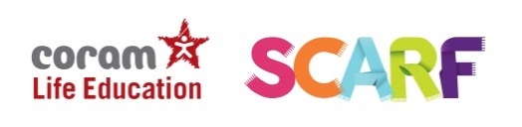

ORDER FORM
Coram Life Education cle@coram.org.uk
Coram Campus 020 7520 0364
41 Brunswick Square
London
WC1N 1AZ

SCHOOL NAME AND URN
STREET ADDRESS DATE: DD/MM/YYYY
POST CODE
PHONE
EMAIL
TICK All THAT APPLY | ITEM | DESCRIPTION – Training  *If you would like more than two training places please email cle@coram.org.uk  * Please specify the date you require for this training in your accompanying email. Dates can be found here. | ITEM PRICE | VAT | TOTAL
 | RSE One Day teacher training | SCARF Subscribers | £75 | £15 | £90
 | RSE One Day teacher training | Non-SCARF Subscribers | £105 | £21 | £126
Payments by BACS:
Coram life Education
Account no: 03617467
Sort code: 18-00-02
*Please put your Order Number in the reference box for BACS payment*
**Please ensure that payments are made to these account details only and not to any other members of the Coram Group**
All cheques payable to:
Coram Life Education
Coram Campus
41 Brunswick Square
London
WC1N 1AZ
020 7520 0364

