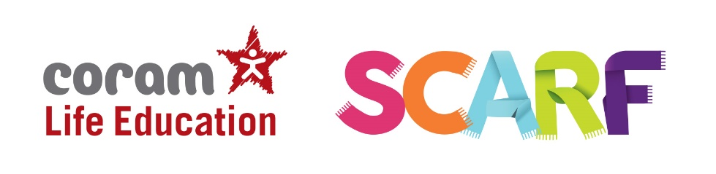

Who are we?
Coram Life Education is the leading UK provider of relationships, health, wellbeing, and drugs education.
Trained Educators use evidence-based, interactive, engaging methods and resources to provide memorable learning experiences for 1 in 10 children in England and Scotland.

What children experience during an educator led workshop from Coram Life Education
Children’s experience of Coram Life Education’s sessions is fun, engaging and memorable. Children meet Harold, our giraffe puppet mascot (‘Healthy Harold’). They have discussions and watch short films about healthy eating, legal and illegal drugs and their effects, the body and how it works, and friendships and their influence. They begin to understand the impact of their choices and behaviours on every aspect of their health and wellbeing – and learn the skills and information needed to make positive, informed health choices.

SCARF
Alongside our mobile classroom, Life Space or in-classroom visits, our online resource, SCARF provide a curriculum and a whole-school framework for building the essential life skills to support physical and emotional wellbeing – crucial for children to achieve their best, academically and socially.
Aligned with Curriculum for Excellence and GIRFEC, SCARF is a complete curriculum consisting of over 350 lesson plans and related assessment that gives teachers the skills and tools to teach a comprehensive health and wellbeing programme throughout the primary years.
What will my child learn in SCARF lessons?
For each year group, there are six suggested themed units which provide a complete health and wellbeing curriculum. They are:

Me and My Relationships
Explores feelings and emotions, develops skills to manage conflict, helps identify our special people and equips children to recognise the qualities of healthy friendships and how to manage them.
Valuing Difference
Supports children to develop respectful relationships with others, recognise bullying and know their responsibilities as a bystander.
Keeping Myself Safe
Covers a number of safety aspects from statutory RSHP including being able to identify trusted adults in their lives, what to do when faced with a dilemma and recognising appropriate and inappropriate touch.
Rights and Responsibilities
Explores broader topics including looking after the environment, economic education and the changing rights and responsibilities children have as they grow older.
Being My Best
Includes a focus on keeping physically healthy, developing a growth mindset to facilitate resiliency, setting goals and ways to achieve them.
Growing and Changing
Has age-appropriate plans to cover the physical and emotional changes that happen as children as they grow older, including changes at puberty and how to approach this with confidence. Age-appropriate lessons on relationships and sex education are also included.

Relationships, Sexual Health and Parenthood
RSHP in primary schools should teach the fundamental building blocks and characteristics of positive relationships, with particular reference to friendships, family relationships, and relationships with other peers and adults. At Coram Life Education we believe that children should learn about relationships as well as the emotional, social and physical aspects of growing up, human sexuality and sexual health in an age-appropriate way. This goes beyond learning about relationships, to include puberty, how a baby is conceived and born, body ownership, and safeguarding. Although we refer to our resources as our Relationship Education programme, they also include other elements of health and wellbeing.
Our RSHP resources help children and young people to be safe, healthy and happy, both as they grow, and in their future lives. These lessons help to meet the curriculum experiences and outcomes from early learning and childcare through to the end of primary school.
A comprehensive set of age-appropriate lesson plans within SCARF online
SCARF RSHP-specific lessons are designed to cover key skills, attitudes and values children need to explore in order to develop healthy relationships with their peers. Children also learn how to keep themselves safe and to ask for help when they need it.
3-5 year-olds: being the same and different, our special people, different families, different homes, our feelings, being unique and special, being kind, caring and friendly, keeping safe, keeping healthy, resilience, life stages and growing from young to old.

5-6 year olds: explores themes around families and their special people, the importance of respecting others including those that are different from us, recognising that genitals are private and their correct names; develops understanding of the difference between surprises and secrets (good or bad secrets) and when not to keep bad adult secrets; helps develop judgement of what kind of physical contact is acceptable or unacceptable and how to respond to this (including who to tell and how to tell them).

6-7 year-olds: looks at the process of growing from young to old and how people’s needs change; explores the opportunities and responsibilities that increasing independence can bring, recognising that they share a responsibility for keeping themselves and others safe.

7-8 year-olds: introduces themes about change, including menstruation and bereavement, healthy and unhealthy relationships (friendships), how images in the media do not always reflect reality and the impact of this on people’s thoughts and feelings; the nature and consequences of discrimination; the importance of protecting personal information online; understanding risk and building resilience; making informed choices; resisting pressure and recognising when and how to ask for help.

8-9 year-olds: builds on the themes covered in previous years, looking more closely at body changes as they approach and move through puberty including: menstruation and human reproduction; conflicting emotions; what positively and negatively affects their physical, mental and emotional health; understanding good and not-so-good feelings; recognising and challenging stereotypes; consequences of their actions; pressures to behave in an unacceptable, unhealthy or risky way and that marriage is a commitment freely entered into by both people.

9-10 year-olds: builds on the themes covered previously and in greater depth, looking more closely at: body changes and feelings during puberty; how their changing feelings can affect those they live with; what makes relationships unhealthy; exploring risky behaviour in more detail; different types of bullying including homophobic and transphobic; how to keep their personal information private online (and why this is important), and how to use social media safely.

10-11 year-olds: builds on and reinforces all the themes of the previous years, with new content built into the lesson plans looking at: body image and the media; forced marriage; female genital mutilation (FGM); sexual intercourse; HIV; and managing pressure online.

What can I do to support my child’s learning at home?
Guidance is clear in recognising that a parent/carer is a child’s primary educator in these matters. There are a many things you can do to support your child’s understanding and encourage them to ask questions. Here are some
- If you feel it is time to talk to your child about growing up and the changes they are likely to experience it’s best to offer it in small chunks, rather than do it in one go, often known as ‘The Talk’. This gives children time to digest the new information and ask you further questions as they develop more understanding.
- If your child asks you questions try to stay calm, and not worry if you don’t know the answer. There are plenty of websites that you can use together to help you find the answers to their questions in a factual, honest, age appropriate way (see details below for resources on our website).
- Use everyday opportunities to bring up the topic; things you see on TV or hear on the radio can be great conversation starters to talk about topics such as relationships, sex and body image. Reading books with your child is also a great way of introducing topics and helping children to understand themselves, their bodies and the world around them.
- If you do have family names for genitals, ensure your child also knows their scientific names too. Nobody likes to think their child is at risk of abuse, but knowing the correct words for their genitals will help them report abuse if it did ever happen.
- By showing your child that you are comfortable with them asking you questions now, you are helping to develop a relationship with them where they can seek your advice and support in their adolescent years.
- Visit the specially created SCARF webpage “Helping your children understand changes at puberty” more information including a list of books and websites that will support both you and your child along with some activities you to support their learning.

